# Use case diagram.pngCS 255 System Design Document Template

This template lays out all the different sections that you need to complete for Project Two. Each section has guidance to prompt your thinking. You will need to continually reference the interview transcript as you work to make sure that you are addressing your client’s needs. There is no required length for the final document. Instead the goal is to complete each section based on what your client’s needs are. Remove this note when you are finished, and replace all bracketed text with the relevant information.

## UML Diagrams

### UML Use Case Diagram

For use case admin also uses login but lucid chart wouldn’t allow for more relations.

### UML Activity Diagrams

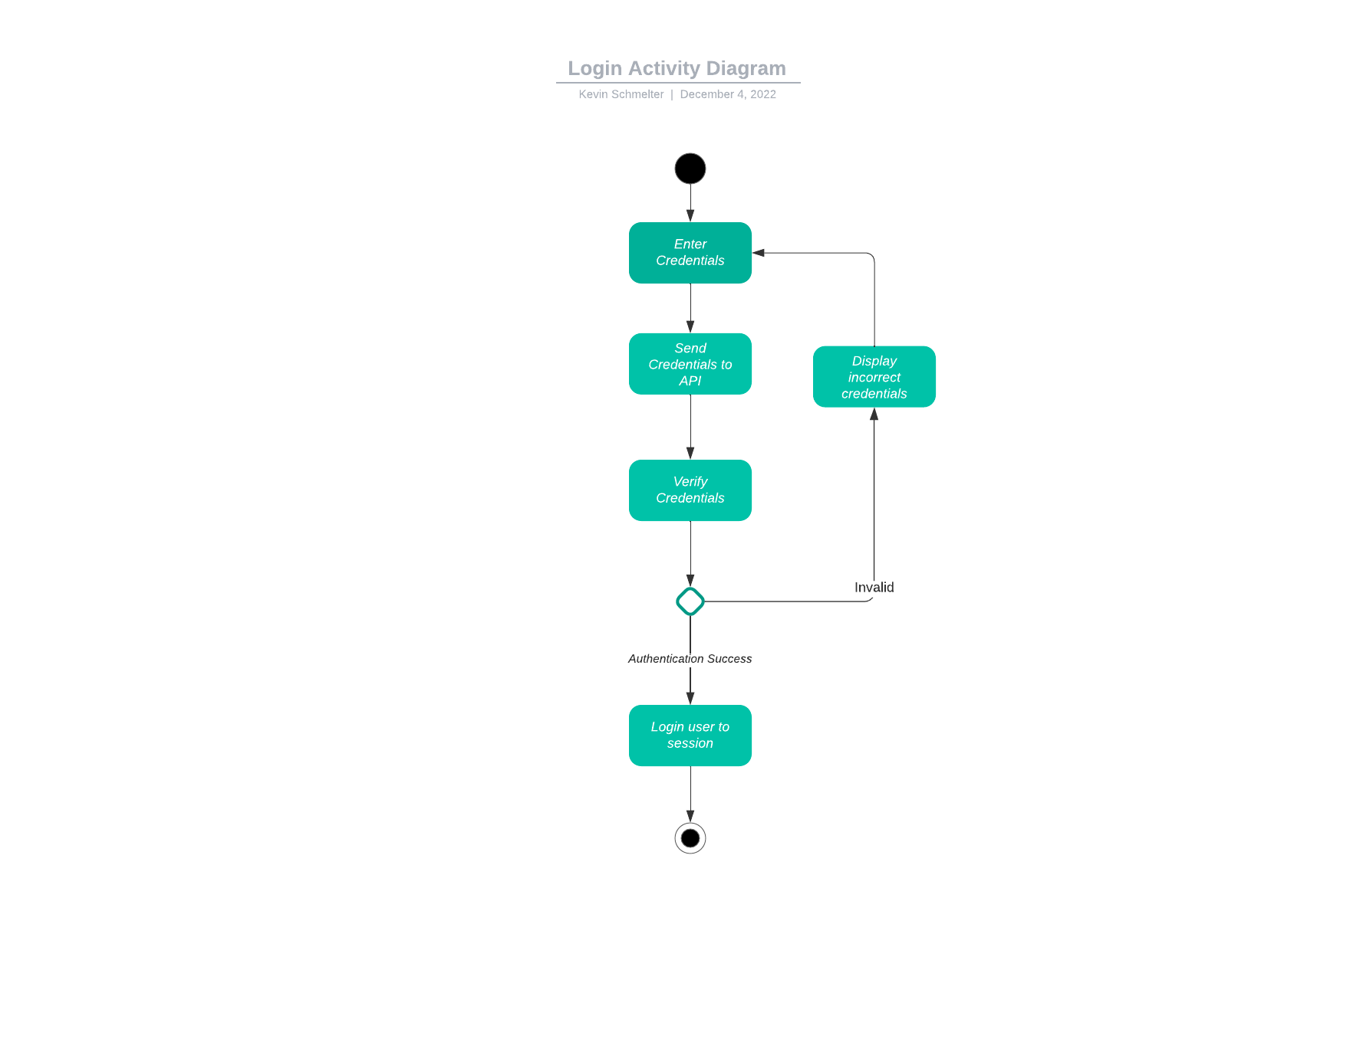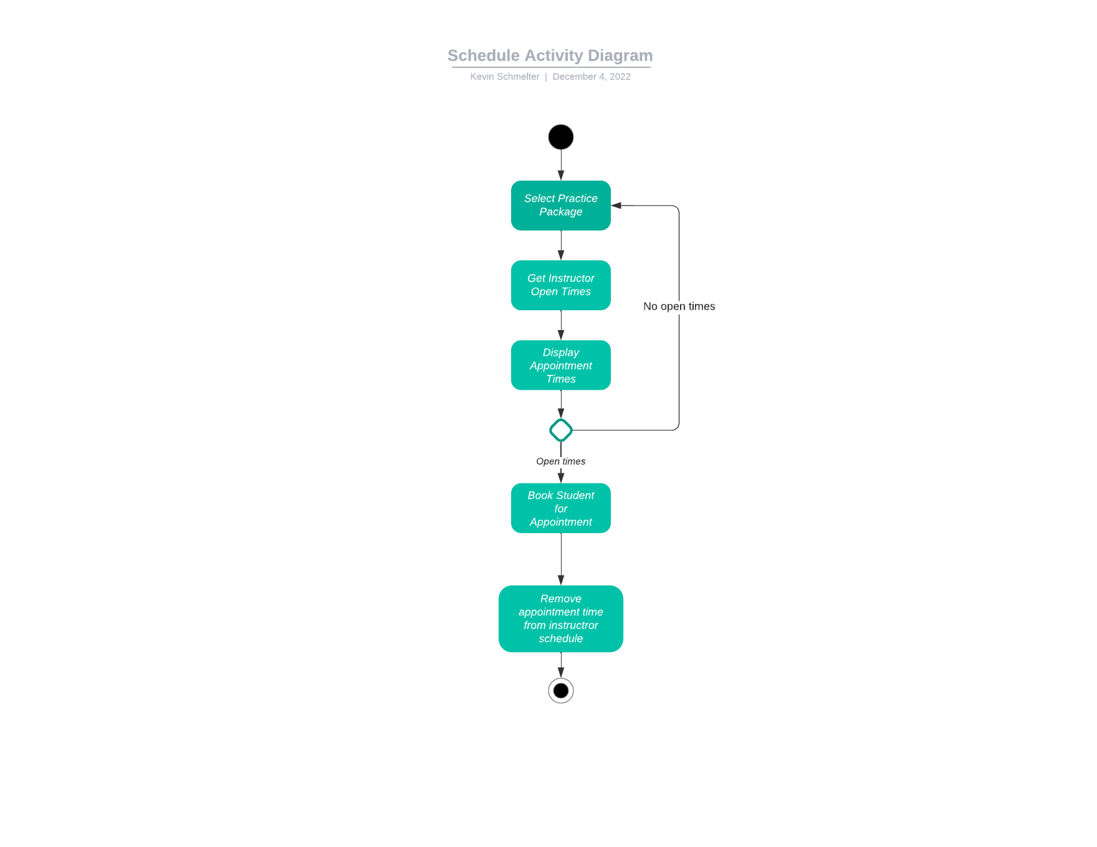

### UML Sequence Diagram

### UML Class Diagram

## Technical Requirements

Looking at the overall structure of the system from the diagrams, we can see that this is a system that needs to be fast, reliable, and scaleable. In order for the system to handle the amount of traffic DriverPass would ideally like, we would use a cloud infrastructure backend so that we can have the servers maintained and managed by a provider. In our case since we are integrating with a previous but not web based system, it is most likely that we can use AWS linux for our cloud infrastructure. Since we are using a cloud provider we can either use an integrated database, or we could use our own. Since we want the application to be available for mobile and web users, we would most likely want to use the MERN (MongoDB, Express.js, React.js, Node.js) stack so that we can use react native on the mobile and web frontend, and have our database and backend services managed by AWS.

